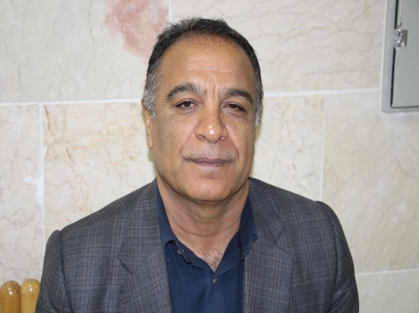Karim Nasseri

Professor of Anesthesiology

Department of Anesthesiology, School of Medicine

Social Determinants of Health Research Center

Research Institute for Health Development

Besat Hospital, Tohid Hospital, Kowsar Hospital

Kurdistan University of Medical Sciences

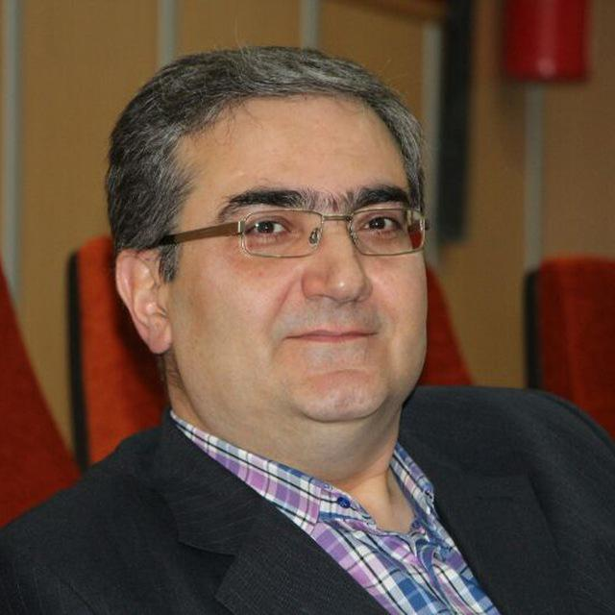

Behzad Ahsan

Associate Professor of Anesthesiology

Department of Anesthesiology, School of Medicine

Tohid Hospital, Kowsar Hospital

Kurdistan University of Medical Sciences

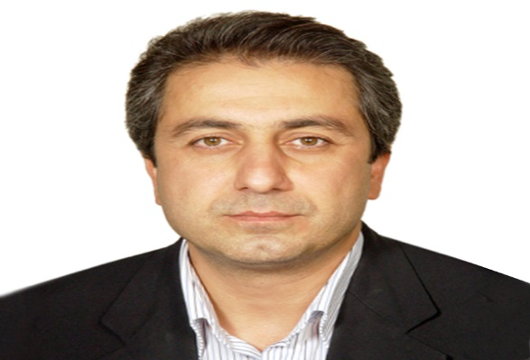Farzad Sarshivi

Assistant Professor of Anesthesiology

Department of Anesthesiology, School of Medicine

Besat Hospital, Tohid Hospital, Kowsar Hospital

Kurdistan University of Medical Sciences

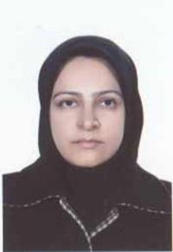Negin Ghadami

Assistant Professor of Anesthesiology

Department of Anesthesiology, School of Medicine

Besat Hospital, Kowsar Hospital

Kurdistan University of Medical Sciences

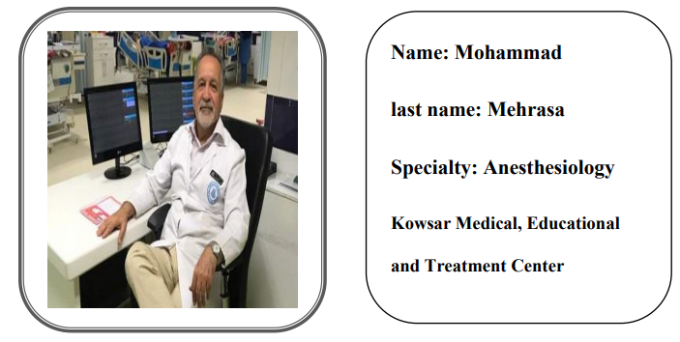

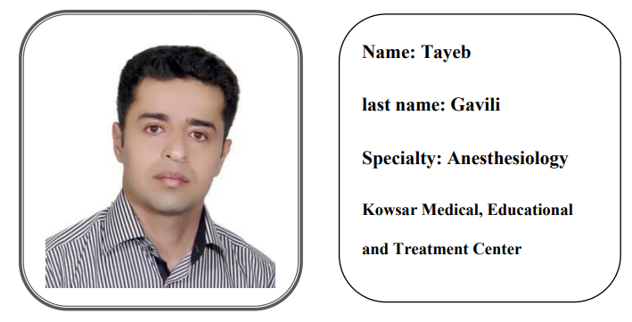

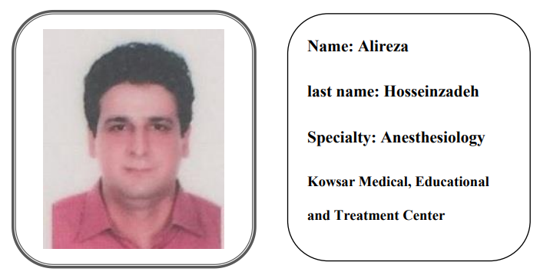

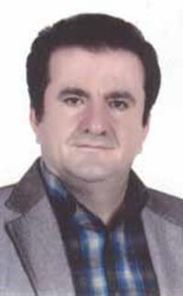Shahrokh Ebnerasooli

Assistant Professor of Anesthesiology

Department of Anesthesiology, School of Medicine

Besat Hospital, Kowsar Hospital

Kurdistan University of Medical Sciences

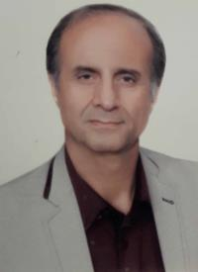Shahpor Shoja

Assistant Professor of Anesthesiology

Department of Anesthesiology, School of Medicine

Besat Hospital, Tohid Hospital

Kurdistan University of Medical Sciences